**5 Exercises**

**Application**

Refer to the Air Quality data described previously, and the analyses we have done with Ozone as the response variable, and the five explanatory variables (including the two engineered features).

Use Neural Nets (NN) to model the relationship between Ozone and all five explanatories

as specified below.:

1. Create a matrix of the five explanatory variables. Rescale each of them to lie between

0 and 1 and same them as another matrix. **Print a summary() of each object to**

**confirm that you have scaled properly.**

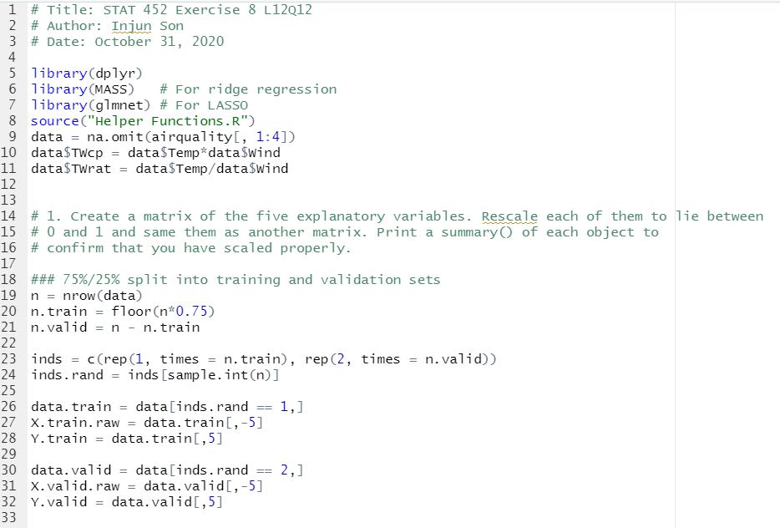

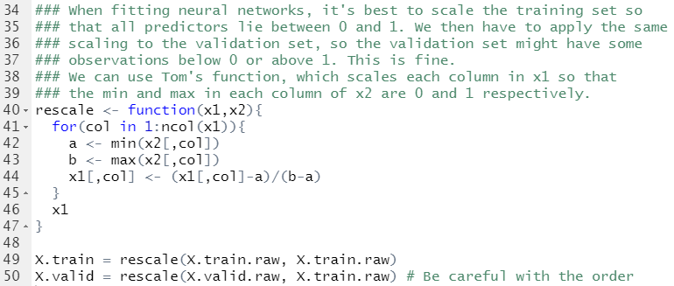

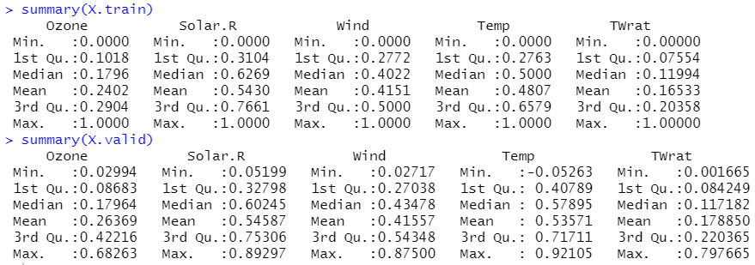

2. Fit 4 NNs nets using only Temp and Wind, using each combination of 2 and 6 hidden

nodes with 0.001 and 1 shrinkage; i,e,; (2,0.001), (2,1), (6,0.001), (6,1)

(a) Refit each one manually 20 times or more and compute the sMSE each time.

1. **Report the sMSE for the optimal fit for each model.**

(2, 0.001)

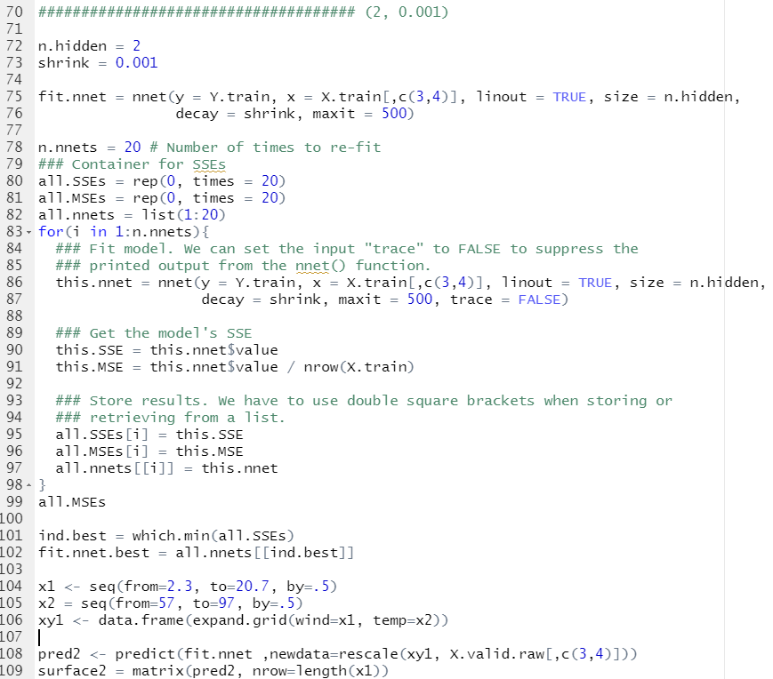

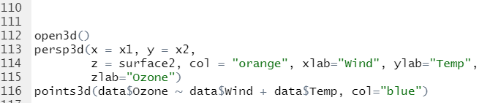



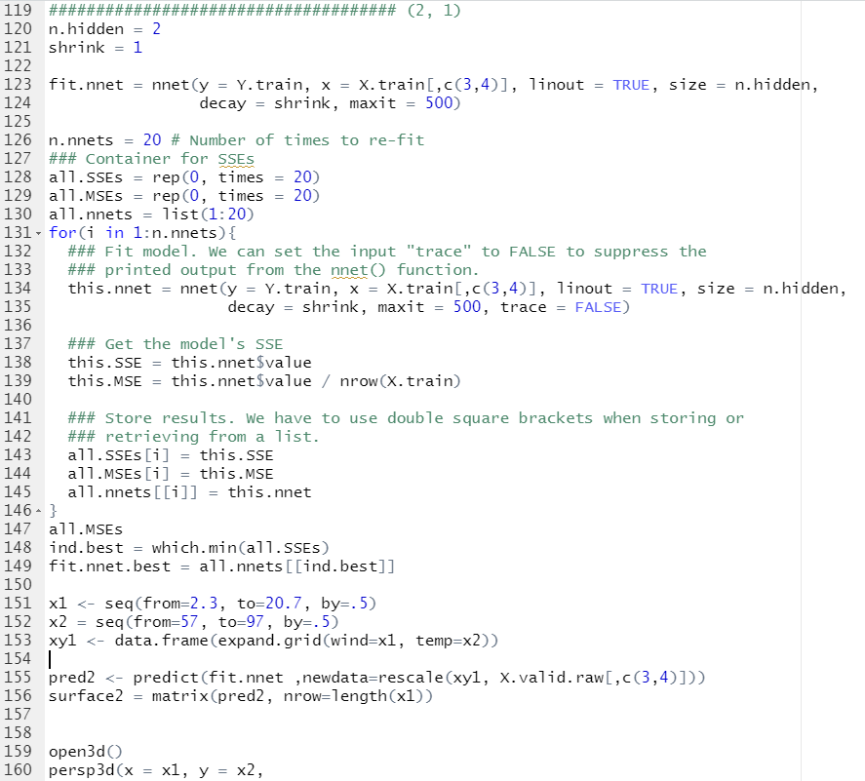

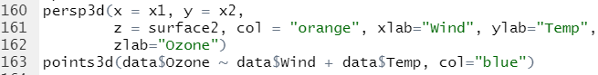



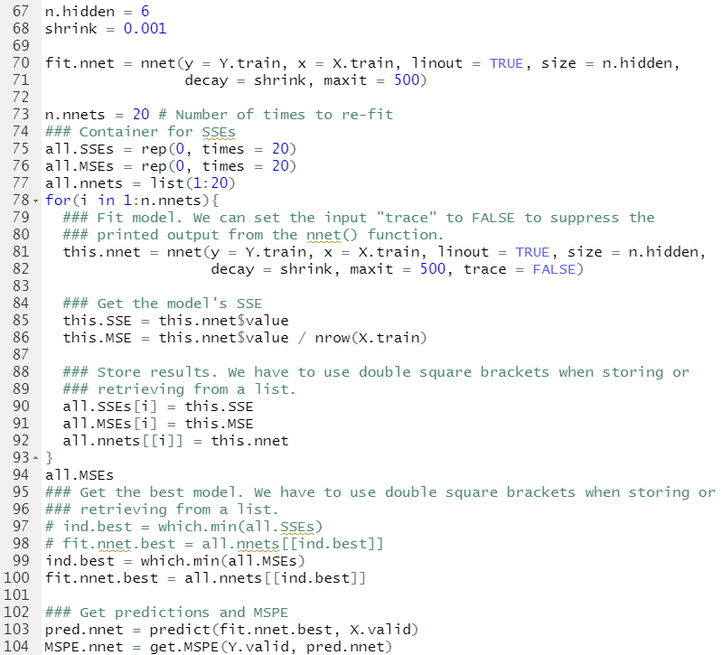



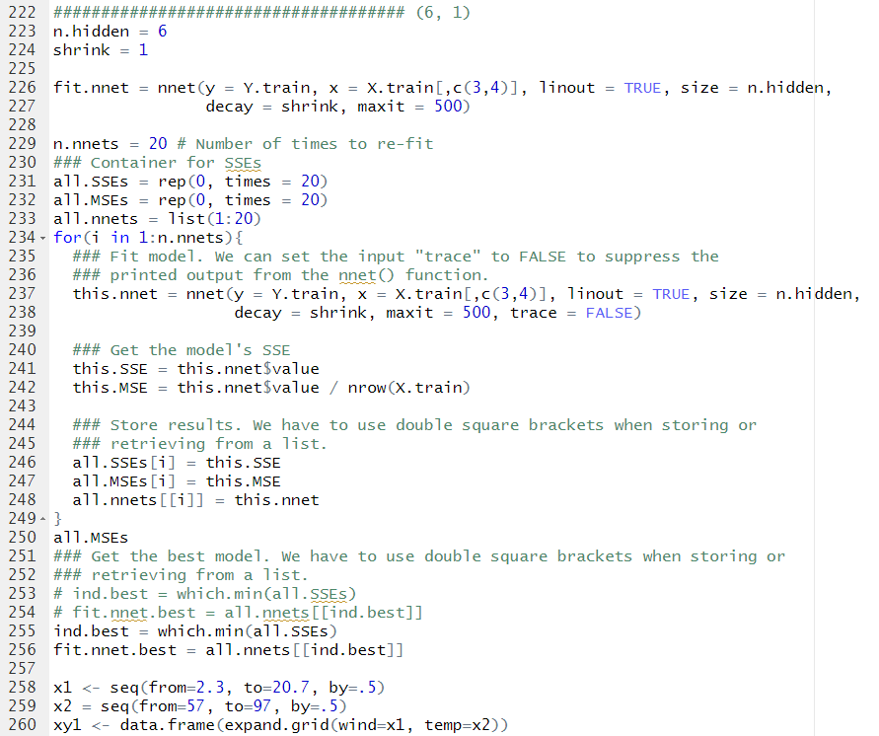

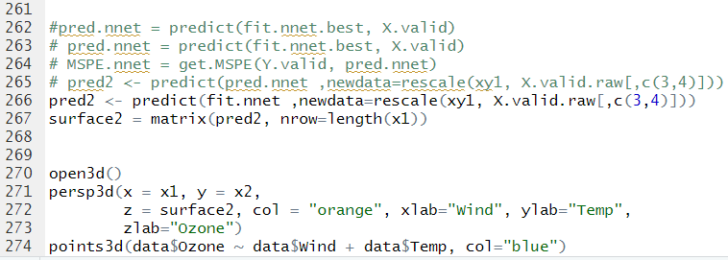



ii. Comment on the stability of fits for different models. In other words, **which**

**models were most/least consistent with the sMSE values produced**

**by different fits?**

**->** Model with 6 hidden nodes and 1 shrinkage has the most consistent sMSE.

->Model with 2 hidden nods and 0.001 shrinkage has the inconsistent sMSE.

(b) Make a 3-D plot of each model’s fit.

i. **Report a screenshot of each fit, rotated to roughly the same angle**

**each time to show a good comparison of the fits.** (I find it best to

look down through the corner with low temp and high wind, so that the high

ozone values are in the back.)

(2, 0.001)

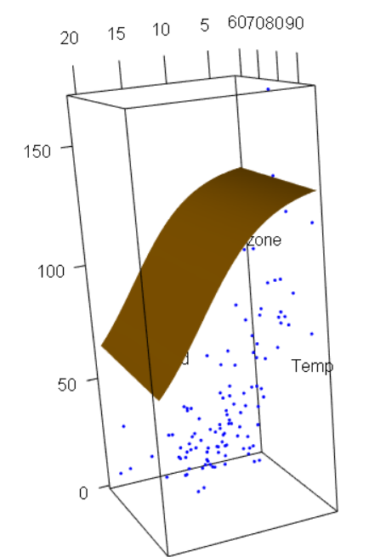

(2, 1)

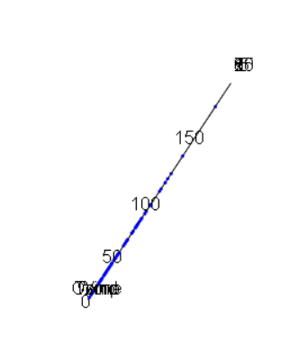

(6, 0.001)

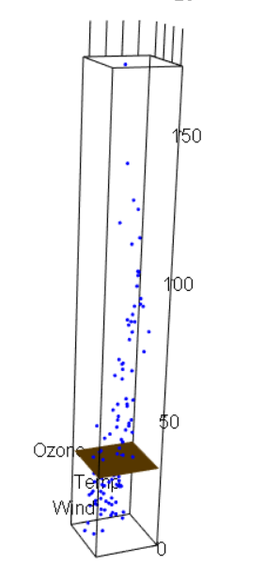

(6, 1)

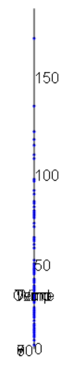

ii. **Comment separately on how increasing number of nodes or increasing**

**shrinkage appears to affect the fits.**

* It looks like increasing shrinkage make more exact fits, but this looks like an over fit.